*Working with Message box and Write line*

*Message box*

. First of all we open the Ui path studio then we go to the process option and a pop out will come and name the process.

. Then we go to the new option and click the sequence and name it.

. From the activities, search the message box and drag it on the sequence.

. The message box output will run on the main desktop.

*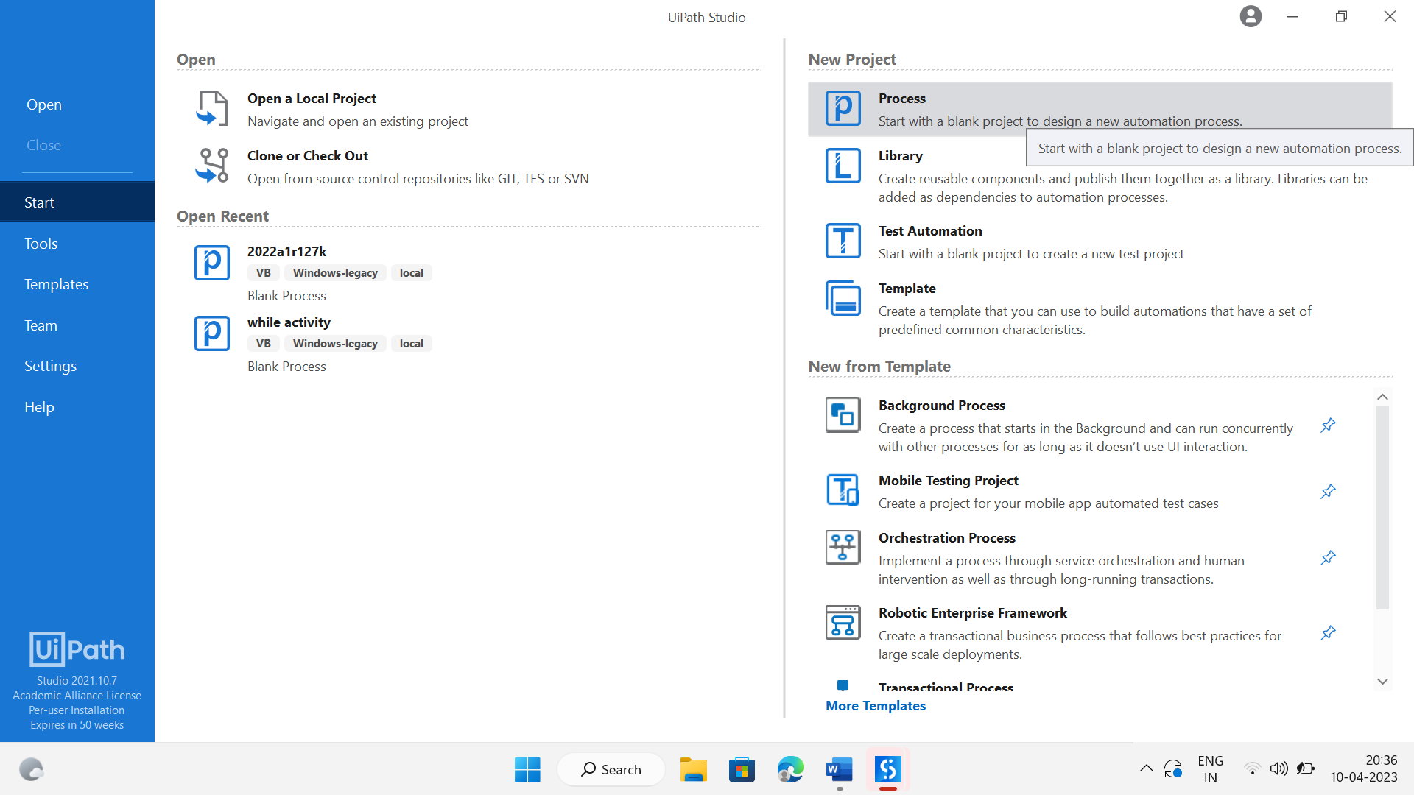*

*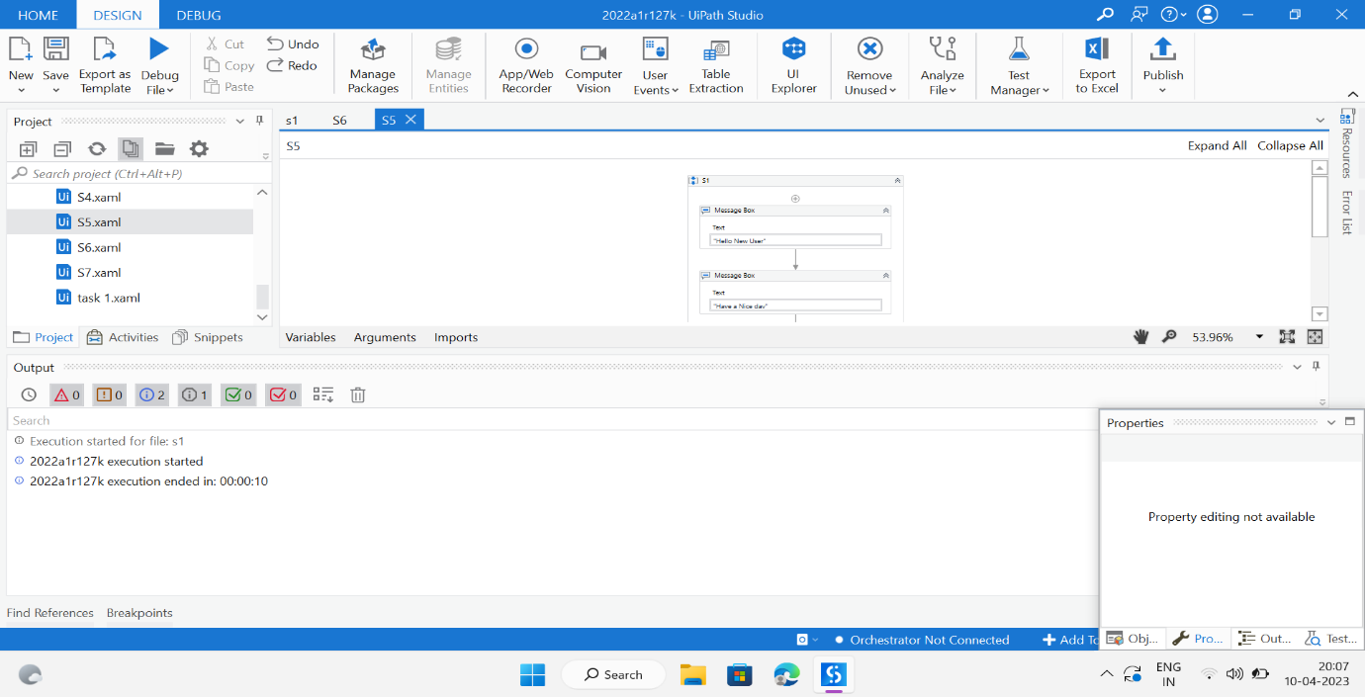*

*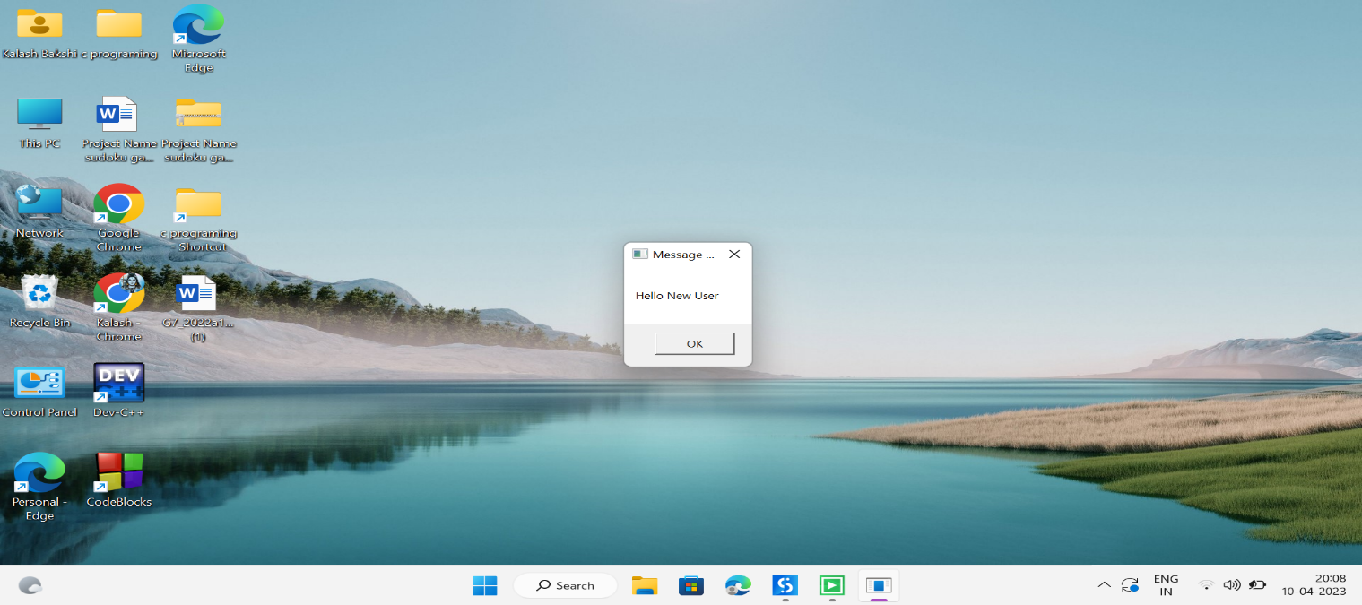*

*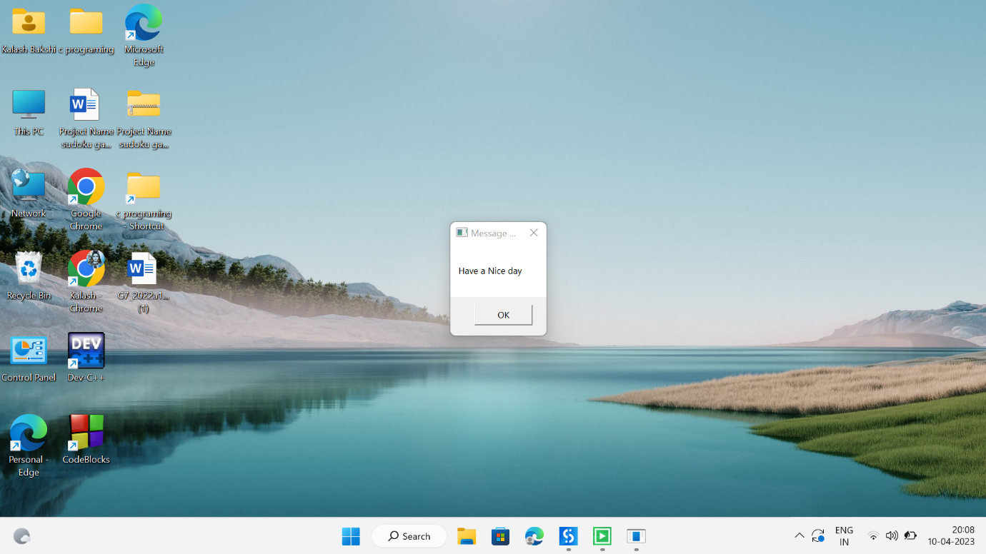*

*Write line*

.First of all open the Ui path studio then we go to the process option and a pop out will come and name the process.

. Then, we go to new option and click the sequence and name it.

. From the activities, search the write line and drag it on the sequence.

. Then output of write line comes in output panel of Ui path Studio.

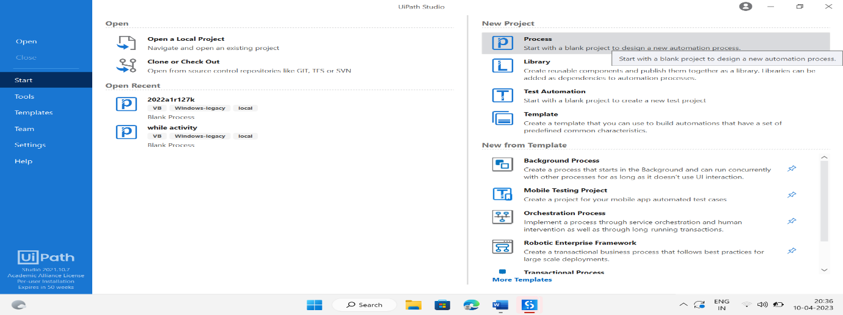

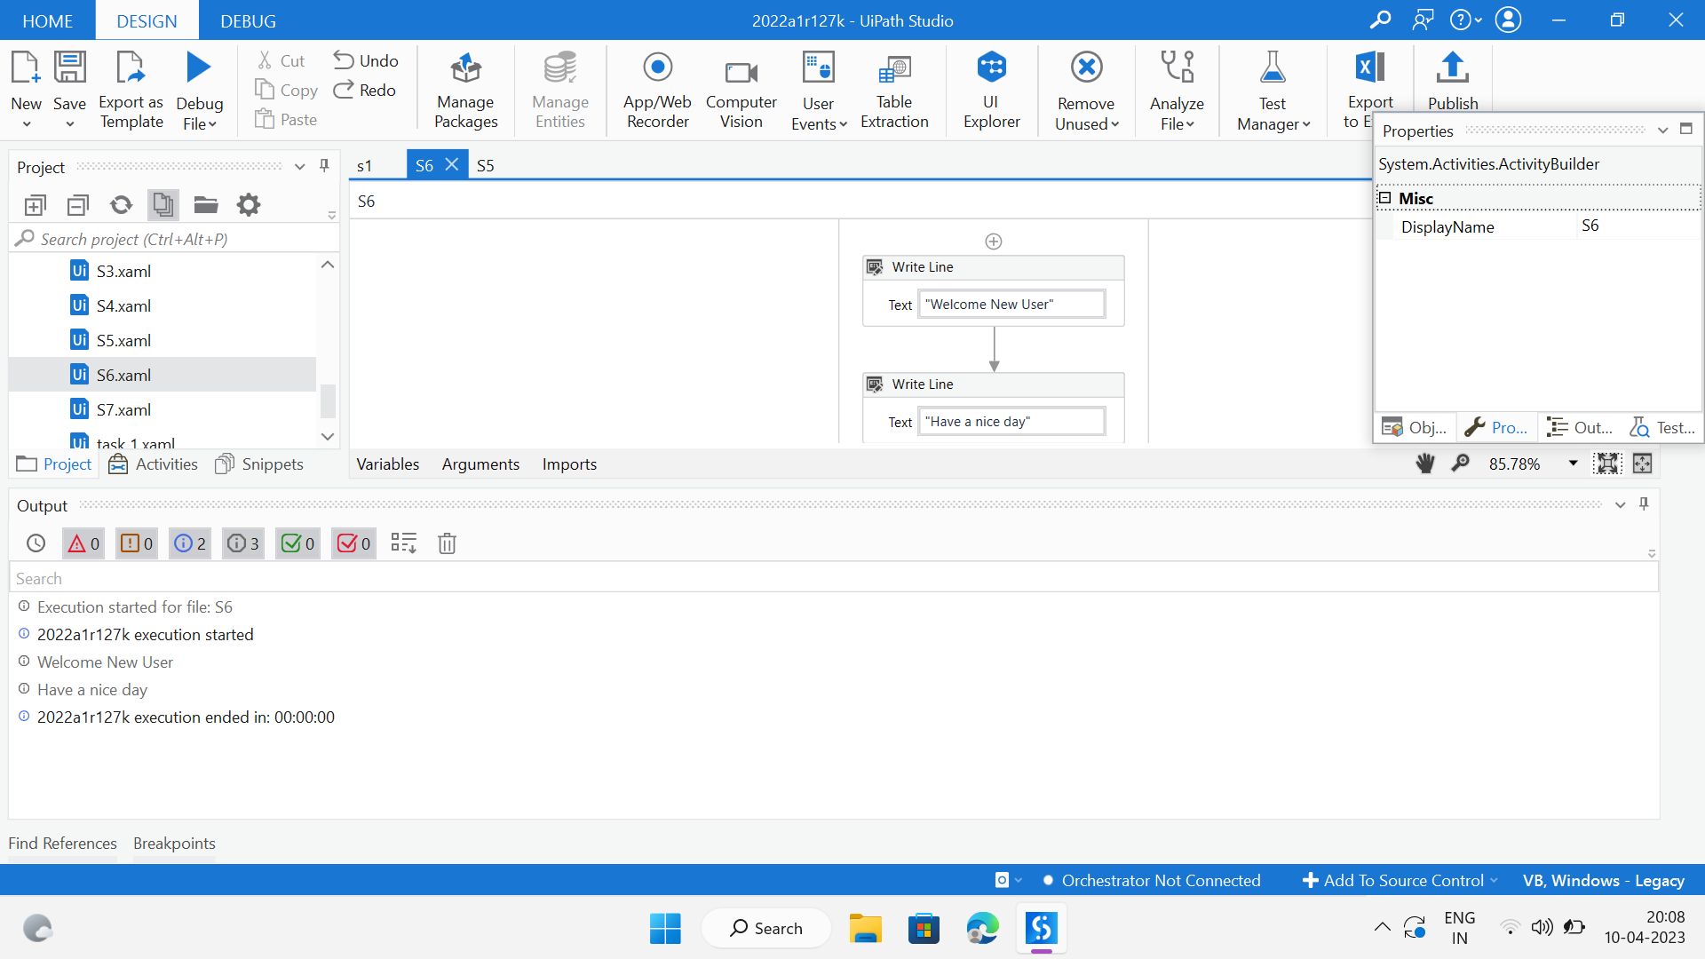

Done